JS -  Blank Validation & Length

Design a webpage that checks the data and displays the warning message or the length of the name using javascript.

lengthThe length property returns the length of a string (number of characters).

Syntax :  var str = "Hello World!"; var n = str.length;

Sample Screenshot 1 :  
  
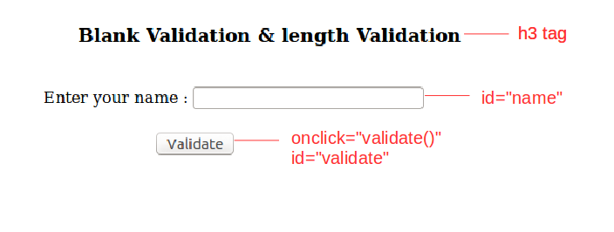Sample Screenshot 2 : 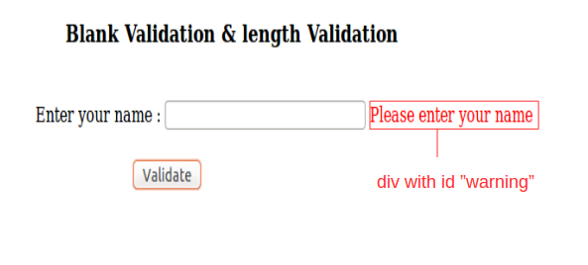Sample Screenshot 3 :  
  
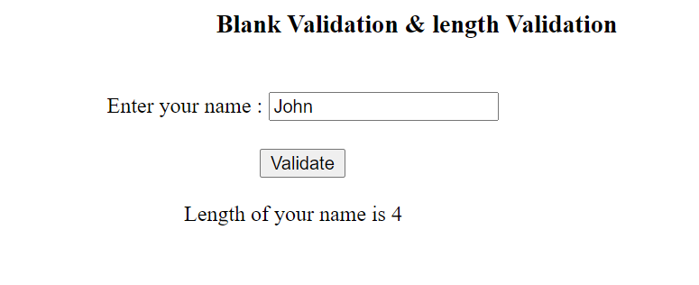  
  
Constraints :  
  
Content of the page should be present as shown in the screenshot.  
This div with id "warning" element must be styled with the color 'ff0000'.  
The <div> element for displaying the success message must have the id "success".  
Only one message should be displayed at a time. Either warning message or success message depending on the input.